**Introduction/Business Problem In a city of your choice, if someone is looking to open a restaurant, where would you recommend that they open it?**

As increasing numbers of consumers want to dine out or take prepared food home, the number of food-service operations has skyrocketed from 155,000 about 40 years ago to nearly 960,000 today. But there's still room in the market for your food-service business.

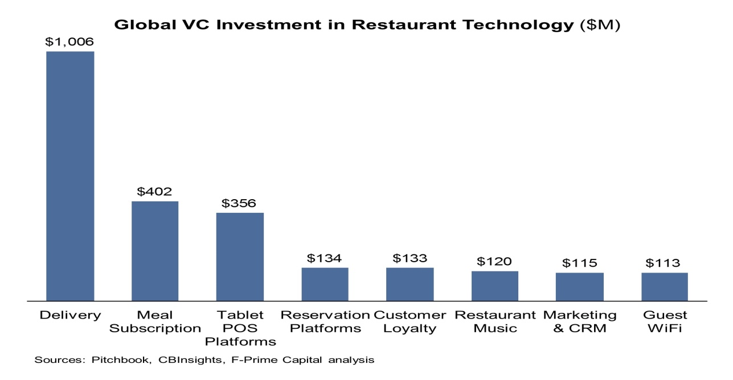

We are going to solve the mentioned problem.